
Complaints Procedure

Organisation | Futures-Essex Ltd
Policy Title | Complaints Procedure
Applies to | Parents/carers, young people, commissioners and other professionals
Approved by | Lauren Collin, CEO
Last reviewed on | July 2026
Next review due by | July 2027 (annual review)
Effective from | 1 September 2026

Contents

Contents 2
1. Aims 3
2. Legislation and Guidance 3
3. Definitions and Scope 3
3.1 Definitions 3
3.2 Scope 3
4. Roles and Responsibilities 4
4.1 The Complainant 4
4.2 The Investigator 4
4.3 The Complaints Co-ordinator 4
5. Accessibility and Inclusion 4
6. Principles for Investigation 5
6.1 Timescales 5
7. Stages of Complaint 5
7.1 Stage 1: Informal 5
7.2 Stage 2: Formal 5
7.3 Escalating to the Advisory Board 6
7.4 Stage 3: Review Panel 6
The Outcome 7
8. Complaints Against the CEO or the Advisory Board 7
9. Safeguarding Distinction 7
10. Complaints Involving Local Authorities and Commissioners 7
11. Complaints from Staff, Partners or Other Professionals 8
12. Referring Complaints to the Department for Education 8
13. Persistent, Unreasonable and Vexatious Complaints 8
13.1 Unreasonably Persistent Complaints 8
Steps We Will Take 9
Stopping Responding 9
13.2 Duplicate Complaints 9
13.3 Complaint Campaigns 9
14. Record Keeping and Confidentiality 9
15. Learning Lessons and Reporting 10
16. Monitoring Arrangements 10
17. Links with Other Policies 10
18. Appendix 1: Complaints Procedure Flow Diagram 11

1. Aims
Futures-Essex Ltd will meet its statutory obligations when responding to complaints from parents/carers, young people, commissioners and others.
When responding to complaints, we will:
- Be impartial and non-adversarial
- Facilitate a full and fair investigation by an independent person or panel, where necessary
- Address all the points at issue and provide an effective and prompt response
- Respect complainants' desire for confidentiality
- Treat complainants with respect and courtesy
- Make sure that any decisions we make are lawful, rational, reasonable, fair and proportionate, in line with the principles of administrative law
- Keep complainants informed of the progress of the complaints process
- Consider how the complaint can feed into our provision improvement and evaluation processes
We will try to resolve concerns or complaints by informal means wherever possible. Where this is not possible, we will follow our formal procedure.
Futures-Essex Ltd will give every complainant the opportunity to complete the complaints procedure in full. We will publicise the existence of this policy and make it available on our website.
Throughout the process, we will be sensitive to the needs of all parties involved, and make any reasonable adjustments needed to accommodate individuals.

2. Legislation and Guidance
This document meets the requirements of section 29 of the Education Act 2002, which requires settings such as ours to have and make available a procedure to deal with all complaints relating to us, and to any community facilities or services we provide.
It is also based on guidance for schools on complaints procedures from the Department for Education (DfE), including the model procedure and the model procedure for dealing with serial and unreasonable complaints, adapted to reflect our status as a non-maintained Alternative Provision and Essex County Council IPES Framework provider.

3. Definitions and Scope

3.1 Definitions
The DfE guidance explains the difference between a concern and a complaint:
- A concern is an expression of worry or doubt over an issue considered to be important, for which reassurance is sought
- A complaint is an expression of dissatisfaction, however made, about actions taken or a lack of action

3.2 Scope
Futures-Essex Ltd will resolve complaints informally where possible, at the earliest possible stage. Complainants will sometimes wish to raise their concerns formally. This policy sets out the procedure for handling such complaints.
This policy does not cover complaints relating to:
- Statutory assessments of special educational needs (SEN)
- Safeguarding matters (see Section 9)
- Whistle-blowing
- Staff grievances
- Staff discipline

4. Roles and Responsibilities

4.1 The Complainant
The complainant will get a more effective and timely response to their complaint if they:
- Follow these procedures
- Co-operate with Futures-Essex Ltd throughout the process, and respond to deadlines and communication promptly
- Ask for assistance as needed
- Treat all those involved with respect
- Do not publish details about the complaint on social media

4.2 The Investigator
An individual will be appointed to look into the complaint and establish the facts. They will:
- Interview all relevant parties, keeping notes
- Consider records and any written evidence, and keep these securely
- Prepare a comprehensive report for the CEO or the review panel, including the facts and potential solutions

4.3 The Complaints Co-ordinator
The complaints co-ordinator will be the Provision Manager, the CEO, or another staff member providing administrative support. The complaints co-ordinator will:
- Keep the complainant up to date at each stage of the procedure
- Make sure the process runs smoothly, by liaising with staff members and all other stakeholders
- Be alert to issues relating to sharing third-party information, and to any additional support a complainant needs, for example interpretation support, or where the complainant is a young person
- Keep records

5. Accessibility and Inclusion
We will make this complaints procedure accessible to young people and families with additional needs, including through easy-read versions, interpreters and advocacy, where these are needed.
We will take complaints from young people themselves seriously, and will handle them using the same process as complaints from parents/carers.

6. Principles for Investigation
When investigating a complaint, we will clarify:
- What has happened
- Who was involved
- What the complainant feels would put things right

6.1 Timescales
The complainant will raise the complaint within 3 months of the incident. If the complaint is about a series of related incidents, they will raise it within 3 months of the last incident.
We will consider exceptions to this timeframe where there were valid reasons for not making a complaint at the time, and the complaint can still be investigated fairly for all involved.
Where complaints are made outside of term time, we will treat them as received on the first day after the holiday period.
If at any point we cannot meet the timescales set out in this policy, we will set new time limits with the complainant, and explain the reason for the delay.

7. Stages of Complaint
This section covers complaints other than those against the CEO or the Advisory Board, which are set out in Section 8.

7.1 Stage 1: Informal
Futures-Essex Ltd will take informal concerns seriously, and will make every effort to resolve the matter quickly. In many cases, providing or clarifying information will resolve the issue.
The complainant will raise the complaint as soon as possible with the relevant member of staff, or the Provision Manager, either in person or by letter, telephone or email. If the complainant is unsure who to contact, they will contact the office on 01245 982888.
We will acknowledge informal complaints within 3 working days, and involve a meeting between the complainant and the Provision Manager or CEO, as appropriate. If the complaint is not resolved informally, it will be escalated to a formal complaint.

7.2 Stage 2: Formal
Formal complaints can be raised by letter, email, phone, in person, or by a third party acting on behalf of the complainant.
The complainant will provide details such as relevant dates, times and the names of witnesses, alongside copies of any relevant documents, and what they feel would resolve the complaint. If complainants need assistance raising a formal complaint, they can contact the office.
The Provision Manager will record the date the complaint is received, and will acknowledge receipt in writing within 3 working days.
The Provision Manager or CEO will call a meeting to clarify concerns and seek a resolution. The complainant will be entitled to be accompanied to this meeting, and will tell Futures-Essex Ltd the identity of their companion in advance.
In certain circumstances — for example, a conflict of interest — Futures-Essex Ltd will need to decline a request for a particular individual to attend a meeting. Where this is the case, we will notify the complainant as soon as we are aware, so they have the opportunity to arrange alternative accompaniment.
The Provision Manager or CEO will then conduct an investigation. The written conclusion will be sent to the complainant within 15 working days of the complaint being received. If the complainant wishes to proceed to the next stage, they will inform us within 5 working days.

7.3 Escalating to the Advisory Board
Complaints can be escalated by contacting the Advisory Board, by letter, email, phone, in person, or through a third party acting on behalf of the complainant.
The Advisory Board will need the details of the complaint as set out above, along with details of how the complainant feels the previous stage did not sufficiently address their complaint, and what they feel would resolve it.
The written conclusion of this investigation will be sent to the complainant within 5 working days. Requests received outside of this timeframe will be considered in exceptional circumstances.

7.4 Stage 3: Review Panel
The review panel will consist of the first 3 members of the Advisory Board available who do not have direct knowledge of the complaint, including at least one independent member not connected to the provision, to strengthen impartiality and align with good practice for schools and alternative provision. Panel members will have access to the existing record of the complaint's progress (see Section 14).
The complainant will be given reasonable notice of the review panel date. If the complainant rejects the offer of 3 proposed dates without good reason, the Directors will set a date, and the hearing will go ahead using written submissions from both parties. Any written material will be circulated to all parties at least 3 working days before the meeting.
The meeting will be held in private. Electronic recordings of meetings or conversations will not normally be permitted, unless a complainant's own disability or special needs require it. We will seek the prior knowledge and consent of all parties before any meeting or conversation takes place, and will record consent in any minutes taken.
At the review panel meeting, the complainant and their representative, as appropriate, will be present, and each will have the opportunity to set out written or oral submissions before the meeting. The complainant will be allowed to attend the panel hearing and be accompanied by a suitable companion if they wish.
We do not encourage either party to bring legal representation, but will consider it on a case-by-case basis — for example, a staff member called as a witness will be entitled to support from their union. Representatives from the media will not be permitted to attend.
At the meeting, each individual will have the opportunity to give statements and present their evidence, and witnesses will be called as appropriate. The panel, the complainant and the Futures-Essex representative will be given the chance to ask and reply to questions. Once both parties have completed presenting their cases, they will be asked to leave, and the evidence will then be considered.
The panel will put together its findings and recommendations, and will provide copies of the hearing minutes and its findings and recommendations to the complainant and, where relevant, the subject of the complaint. A copy will also be made available for inspection by the CEO.

The Outcome
The panel will:
- Uphold the complaint, in whole or in part; or
- Dismiss the complaint, in whole or in part
If the complaint is upheld, the panel will decide the appropriate action to resolve it, and will, where appropriate, recommend changes to our systems or procedures to prevent similar issues in future.
We will inform those involved of the decision in writing within 5 working days.
The table below summarises the timescales for each stage.
Stage | Acknowledgement | Outcome
Stage 1 — Informal | Within 3 working days | Within 10 working days
Stage 2 — Formal | Within 3 working days | Within 15 working days
Stage 2 — Escalation to the Advisory Board | Within 3 working days | Within 5 working days
Stage 3 — Review Panel | Convened within 20 working days | Written decision within 5 working days of the hearing

8. Complaints Against the CEO or the Advisory Board
Where a complaint is about the CEO personally, rather than about Futures-Essex Ltd more generally, the complainant will raise it directly with the Advisory Board, following the process set out in Section 7.3.
Where a complaint is about a member of the Advisory Board, or about the Advisory Board as a whole, the complainant will raise it in writing with the CEO, who will convene a review panel under Section 7.4 made up of Advisory Board members with no connection to the complaint, including at least one independent member.
In either case, the same principles, timescales and standards of impartiality set out elsewhere in this policy will apply.

9. Safeguarding Distinction
Safeguarding matters are excluded from this policy. Any complaint that raises a safeguarding concern will be directed immediately to our Designated Safeguarding Lead (DSL), or, where appropriate, to the Essex Safeguarding Children Partnership, rather than being handled through the stages set out in Section 7.
If a safeguarding concern comes to light during a complaint that was raised for another reason, we will pause the complaints process for that element and follow our safeguarding procedures without delay, in line with our Safeguarding and Child Protection Policy.

10. Complaints Involving Local Authorities and Commissioners
Where a young person's placement is commissioned by a local authority — for example, Essex County Council or Southend-on-Sea City Council — we will inform the relevant commissioner of any complaint relating to safeguarding, provision quality, or placement suitability, in line with our commitment to transparent, collaborative working with commissioners.

11. Complaints from Staff, Partners or Other Professionals
This policy is not limited to parents/carers and young people. External professionals — including social workers, therapists and partner schools — can also raise a complaint using this procedure, and will be treated with the same standards of fairness and timeliness set out throughout this policy.
Complaints from Futures-Essex staff about employment matters are handled under our staff grievance and disciplinary procedures, not this policy (see Section 3.2).

12. Referring Complaints to the Department for Education
If the complainant is not satisfied with the outcome of our complaints procedure, they can refer their complaint to the Department for Education (DfE). Following the closure of the Education and Skills Funding Agency (ESFA) in March 2025, this function now sits directly within the DfE.
The DfE will check whether the complaint has been dealt with properly. The DfE will not overturn our decision about a complaint, but will intervene if we have:
- Breached a clause in our funding agreement
- Failed to act in line with our duties under education law
- Acted, or proposed to act, unreasonably when exercising our functions
If our complaints procedure is found not to meet regulations, Futures-Essex Ltd will be asked to correct it accordingly.
Complaints can be referred to the DfE via the customer help portal at gov.uk/complain-to-dfe, or by writing to: Customer Service Team, Department for Education, Cheylesmore House, Quinton Road, Coventry, CV1 2WT.

13. Persistent, Unreasonable and Vexatious Complaints

13.1 Unreasonably Persistent Complaints
Most complaints raised will be valid, and we will treat them seriously. A complaint will be considered unreasonable where the person:
- Has made the same complaint before, and it has already been resolved through this procedure
- Makes a complaint that is obsessive, persistent, harassing, prolific, defamatory or repetitive
- Insists on pursuing a complaint that is unfounded, or out of scope of this procedure, beyond all reason
- Pursues a valid complaint, but in an unreasonable manner — for example, refuses to articulate the complaint, refuses to co-operate with this procedure, or insists it is dealt with in ways incompatible with this procedure and its timeframes
- Makes a complaint designed to cause disruption, annoyance or excessive demands on staff time
- Seeks unrealistic outcomes, or a solution that lacks any serious purpose or value
We are committed to protecting the wellbeing of our staff. Repeated hostile or aggressive communication will be addressed robustly, and support will be offered to any staff member involved.

Steps We Will Take
We will take every reasonable step to address the complainant's concerns, and will give them a clear statement of our position and their options. We will maintain our role as an objective arbiter throughout the process, including in meetings with individuals, and will follow this complaints procedure as normal wherever possible.
If the complainant continues to contact us in a disruptive way, we will put communications strategies in place, which will include one or more of the following:
- Giving the complainant a single point of contact via an email address
- Limiting the number of times the complainant can make contact, such as a fixed number per term
- Asking the complainant to engage a third party to act on their behalf, such as Citizens Advice
- Any other strategy necessary in the circumstances

Stopping Responding
We will stop responding to a complainant when all of the following are met:
- We believe we have taken all reasonable steps to help address their concerns
- We have provided a clear statement of our position and their options
- The complainant contacts us repeatedly, and we believe their intention is to cause disruption or inconvenience
Where we stop responding, we will inform the individual that we intend to do so, and will explain that we will still consider any new complaints they make.
In response to any serious incident of aggression or violence, we will immediately inform the police, and will communicate our actions in writing. Where necessary, this will include barring an individual from our site.

13.2 Duplicate Complaints
If we have resolved a complaint under this procedure and receive a duplicate complaint on the same subject from a partner, family member or other individual, we will assess whether there are aspects we had not previously considered, or new information to take into account.
If we are satisfied there are no new aspects, we will tell the new complainant that we have already investigated and responded to the issue, and that our process is complete. If there are new aspects, we will follow this procedure again.

13.3 Complaint Campaigns
Where Futures-Essex Ltd receives a large volume of complaints about the same topic, especially from complainants unconnected to us, we will respond by publishing a single response on our website, and/or sending a template response to all complainants. If complainants are not satisfied with this response, or wish to pursue the complaint further, our normal procedure will apply.

14. Record Keeping and Confidentiality
Futures-Essex Ltd will record the progress of all complaints, including actions taken at every stage, the stage at which the complaint was resolved, and the final outcome. Our records will include copies of letters and emails, and notes relating to meetings and phone calls.
This material will be treated as confidential and stored securely, and will be viewed only by those investigating the complaint or sitting on the review panel, except where the Secretary of State (or someone acting on their behalf), or the complainant, requests access through a freedom of information request or a subject access request under data protection law, or where the material must be made available during an inspection.
Records of complaints will be kept securely, only for as long as necessary, in line with data protection law and our privacy notices.

15. Learning Lessons and Reporting
The Advisory Board will review any underlying issues raised by complaints and, respecting confidentiality, will determine whether there are improvements Futures-Essex Ltd can make to its procedures or practice, to help prevent similar events in future.
Outcomes of complaints will be reviewed annually by the Advisory Board, with themes and learning points shared with commissioners where appropriate, to support wider service improvement.

16. Monitoring Arrangements
The Advisory Board will monitor the effectiveness of this complaints procedure, to make sure complaints are handled properly. This policy will be reviewed annually.

17. Links with Other Policies
This policy should be read in conjunction with:
- Safeguarding and Child Protection Policy
- Staff grievance procedures
- Staff disciplinary procedures
- Privacy notices

18. Appendix 1: Complaints Procedure Flow Diagram
This diagram summarises the process set out in Sections 7 to 9, from a concern being raised through to referral to the Department for Education.
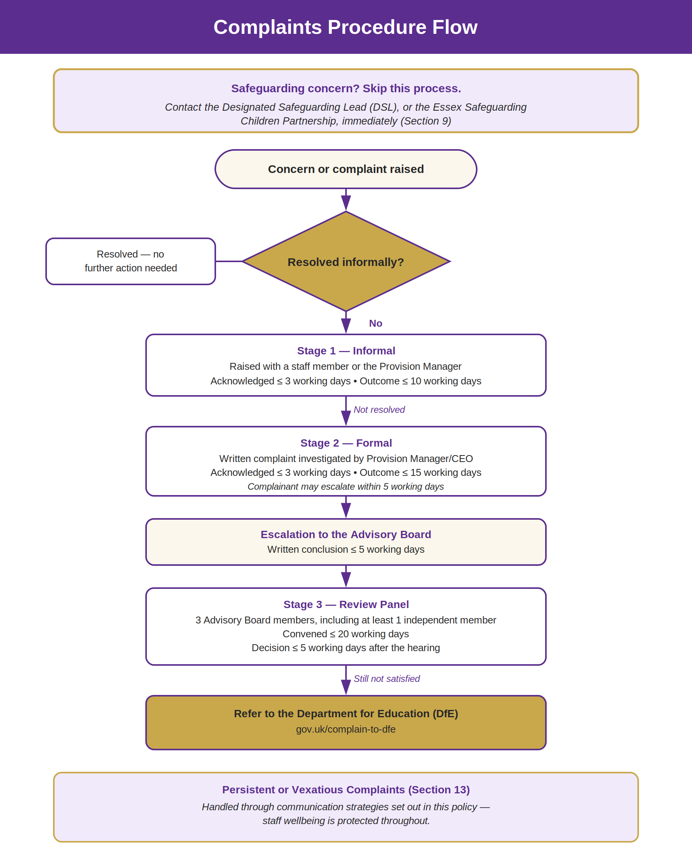

Staff Quick Reference: Complaints Procedure
A one-page summary for staff. This does not replace the full policy — see the sections above for detail.
Stage 1 — Informal  - Raised with a staff member or the Provision Manager.  - Acknowledge within 3 working days; resolve within 10. | Stage 2 — Formal  - Written complaint, investigated by Provision Manager/CEO.  - Acknowledge within 3 working days; outcome within 15.  - Complainant can escalate to the Advisory Board within 5 working days.
Stage 3 — Review Panel  - 3 Advisory Board members, at least 1 independent.  - Convene within 20 working days; decide within 5 of the hearing. | Still Not Resolved?  - Refer to the Department for Education — gov.uk/complain-to-dfe.  - DfE checks process, not the decision itself.
Safeguarding Concern? Stop — Different Process
- Don't run this procedure. Go straight to the DSL, or the Essex Safeguarding Children Partnership.
- If a safeguarding issue surfaces mid-complaint, pause that element and follow safeguarding procedures immediately.
Always Remember
- Use definite language — ‘will’, not ‘may’ — when telling a complainant what we'll do.
- Commissioned placement? Inform the LA/commissioner of any safeguarding, quality or suitability complaint.
- Persistent or hostile complainant? Use the communication strategies in Section 13 — staff wellbeing matters.
- Keep records of everything — letters, emails, meeting and call notes — stored securely.
Listen early. Respond clearly. Follow it through.

